**Week 4: RPL**

**Quiz on routing principles (1/2)**

**1.**

Question 1

Which of the following actions illustrates the concept of forwarding?

1 point

Sending a data packet to the next hop towards its destination

Choosing the best path towards a destination

**2.**

Question 2

Which of the following actions illustrates the concept of routing?

1 point

Sending a data packet to the next hop towards its destination

Choosing the best path towards a destination

**3.**

Question 3

A routing protocol defines the data exchange procedures between devices and their format.

1 point

True

False

**4.**

Question 4

What property of inter-domain routing protocols indicates that autonomous systems hide their performance and topology?

1 point

Confidentiality

Autonomy

Scalability

**5.**

Question 5

What property of inter-domain routing protocols indicates that the administrator of an autonomous systems (AS) is free to choose the IGP (i.e., the intra-domain routing protocol) implemented in its AS?

1 point

Autonomy

Confidentiality

Scalability

**6.**

Question 6

Can two autonomous systems use different internal routing protocols (IGP)?

1 point

Yes

No

**Quiz on routing principles (2/2)**

**1.**

Question 1

How many ASes are forming the Internet?

1 point

720

1400

12000

72000

200000

The following figure shows a network topology with 8 routers and 10 links with a cost of 1.

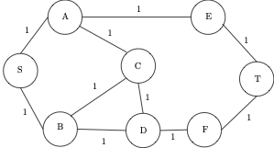

**2.**

Question 2

Which of the following path is the shortest from S to T?

1 point

S-A-E-T

S-A-C-D-F-T

S-B-D-F-T

S-B-C-D-F-T

S-B-C-A-E-T

The administrator of the network has put different weights on the links. The cost of the path is the sum of the weights of the links that are used.

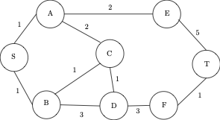

**3.**

Question 3

Which of the following path is the shortest from S to T (i.e., the path with the lowest cost)?

1 point

S-A-E-T

S-A-C-D-F-T

S-B-D-F-T

S-B-C-D-F-T

S-B-C-A-E-T

**4.**

Question 4

What is the cost of this shortest path?

7

1 point

**5.**

Question 5

Computing the shortest path manually, which of the following role did you take?

1 point

Relaying

You acted as the routing protocol

You acted as the routing algorithm

**6.**

Question 6

The routing algorithm is executed by ...

1 point

S only

S and T only

All the nodes

**7.**

Question 7

The format of the packets exchanged to discover the topology is specified by ....

1 point

each nodes of the network

the routing protocol

the routing algorithm

the administrator of the network

**Quiz on RPL:**

**1.**

Question 1

RPL is ...

1 point

A routing algorithm

A routing protocol

A network controller

An energy- constrained network

**2.**

Question 2

The relaying function is performed by ...

1 point

the RPL data plane

the RPL control plane

**3.**

Question 3

What is the routing objective function of RPL used for?

1 point

To change the packet format and reduce its length

To select the prefered parent and minimize the cost of routing

To advertize the adresses used in the LLN

**4.**

Question 4

Two different DODAGs will have

1 point

different DODAG IDs

the same DODAG ID

**5.**

Question 5

An instance of RPL can imply several DODAGS...

1 point

No, it can only imply one DODAG

Yes, it can imply several DODAGs potentally addressing different routing optimization objectives

**6.**

Question 6

Traffic going from a device to the root of the LLN is forwarded along...

1 point

Downward routes

Upward routes

**7.**

Question 7

Multicast communications are performed with...

1 point

point-to-point communications

point-to-multipoint communications

multipoint-to-point communications

**Practice quiz: Exercise on RPL:**

In this exercise, you will explore the way data is forwarded in a DODAG in a multipoint-to-point manner. You will identify the impact of such communication model on the energy consumption of the devices.

Let's take the example of a LLN network runing RPL. The DODAG is given by the Figure 1.

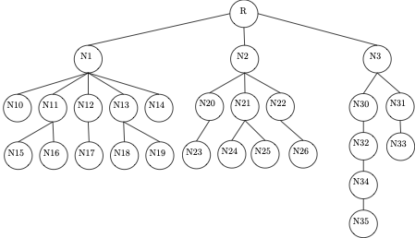

The LLN is composed of one root (node R) and 27 sensors (nodes N1 to N35) that aim at measuring temperatures periodicaly.

Each sensor has an energy budget of 10 (as shown in Figure 2). To send their data, each device uses 1 unit of energy. They also use 1 unit of energy each time they relay a packet towards the root.

We suppose that each device generates a temperature data to be sent to the root every 10 seconds.

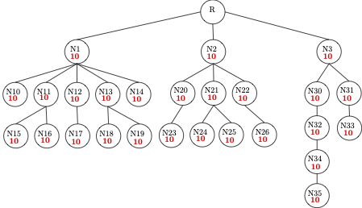

**1.**

Question 1

How many temperature data can the N35 node potentially send before it runs out of energy?

10

**2.**

Question 2

Node N34 sends its temperature data and relays the data from N35. How many temperature data that it has measured itself can node N34 potentially send before it runs out of energy?

5

Every node (N1 to N35) sends one value of temperature.

**3.**

Question 3

After this what will be the remaining energy of node N3?

3

**4.**

Question 4

After this what will be the remaining energy of node N2?

2

**5.**

Question 5

After this what will be the remaining energy of node N1?

0

**6.**

Question 6

Is N1 able to relay every value from its children and its own before runing out of energy?

1 point

Yes

No

**Practice quiz: Exercise on Objective Function OF0:**

Lets take the example of this simple DODAG where we already computed the rank of the root and N1 with the default values.

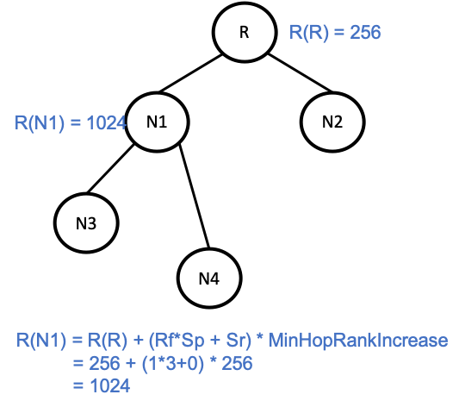

Figure 1: The computation of the rank of node N1

We recall here the equations and the contants used as default values:

**R(N) = R(P) + rank_increase** with R(N) the rank of the node, R(P) the rank of its parent

**rank_increase = (Rf*Sp + Sr) * MinHopRankIncrease**

Rf is a rank factor , its value varies between the constants MINIMUM_RANK_FACTOR and MAXIMUM_RANK_FACTOR.

Sp (step_of_rank) is a value that takes the link properties with a certain neighbor into account. It can be stretch by a parameter Sr (although the RFC 6552 mentions that it is not recommended to stretch the step_of_rank). The stretched step_of_rank varies between MINIMUM_STEP_OF_RANK and MAXIMUM_STEP_OF_RANK. The RFC 6552 recommands to base the computation of the step_of_rank on a dynamic link property, for example the ETX metric (Expected Transmission Count).

The RFC 6552 sets the constants to the following values:

* DEFAULT_STEP_OF_RANK = 3
* MINIMUM_STEP_OF_RANK = 1
* MAXIMUM_STEP_OF_RANK = 9
* DEFAULT_RANK_STRETCH = 0
* MAXIMUM_RANK_STRETCH = 5
* DEFAULT_RANK_FACTOR = 1
* MINIMUM_RANK_FACTOR = 1
* MAXIMUM_RANK_FACTOR = 4
* DEFAULT_MIN_HOP_RANK_INCREASE = 256
* the RFC6550 sets the rank of the root to the value MinHopRankIncrease

By default, the rank_factor is set to DEFAULT_RANK_FACTOR, the maximum stretch_of_rank is set to DEFAULT_RANK_STRETCH, the MinHopRankIncrease is set to DEFAULT_MIN_HOP_RANK_INCREASE.

**1.**

Question 1

What is the value of the rank computed for N2?

256+(1*3+0)*256=1024

**2.**

Question 2

What is the value of the rank computed for N3?

1024+(1*3+0)*256=1536

**3.**

Question 3

What is the value of the rank computed for N4?

1024+(1*3+0)*256=1536

**Quiz exercise on the objective function OF0 and ETX**

The goal of the exercise is to take into account the ETX metric in the OFO objective function to calculate the rank of the nodes of a DODAG.

We recall here the equations and the contants used as default values:

**R(N) = R(P) + rank_increase** with R(N) the rank of the node, R(P) the rank of its parent

**rank_increase = (Rf*Sp + Sr) * MinHopRankIncrease**

Rf is a rank factor , its value varies between the constants MINIMUM_RANK_FACTOR and MAXIMUM_RANK_FACTOR.

Sp (step_of_rank) is a value that takes the link properties with a certain neighbor into account. It can be stretch by a parameter Sr (although the RFC 6552 mentions that it is not recommended to stretch the step_of_rank). The stretched step_of_rank varies between MINIMUM_STEP_OF_RANK and MAXIMUM_STEP_OF_RANK. The RFC 6552 recommands to base the computation of the step_of_rank on a dynamic link property, for example the **ETX metric** (Expected Transmission Count).

**Taking the ETX Metric into account**

Lets recall the definition of the ETX metric :

*"Expected Transmission Count (ETX Metric): The expected number of transmissions to reach the next hop is determined as the inverse of the link PDR*. Consequently, in every hop, if the link quality (PDR) is high, the expected number of transmissions to reach the next hop may be as low as 1. However, if the PDR for the particular link is low, multiple transmissions may be needed."* (source : RFC6687)

* PDR : Packet Delivery Ratio

The ETX metric is defined in RFC 6551. It gives an example of formula to compute it :

ETX = 1(��∗��)(*Df*​∗*Dr*​)1​ where where ��*Df*​ is the measured probability that a packet is received by the neighbor and ��*Dr*​ is the measured probability that the acknowledgment packet is successfully received.

In the following, we will consider:

* a rank factor ��=1*Rf*​=1,
* a step of rank given by ��=(3∗���−2)*Sp*​=(3∗*ETX*−2),
* a stretch of rank ��=0*Sr*​=0,
* MinHopRankIncrease = DEFAULT_MIN_HOP_RANK_INCREASE = 256

To simplify the calculations, we suppose that each link has the same ETX metric value

**1.**

Question 1

When the last 100 data have been transmitted, 100 have been received but only 75 acknoledgements have been received. So ��=1*Df*​=1 and ��=0.8*Dr*​=0.8. What is the value of the ETX metric of the link ?

1 point

1

0.8

1.25

0.005

Lets take the example of this simple DODAG where we already computed the rank of the root and N1 with the default values. To simplify the calculations, we suppose that each link has the same ETX metric value of 1.33.

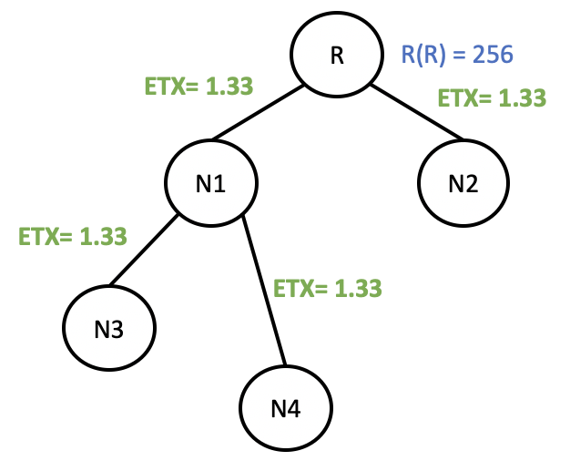

**2.**

Question 2

With the given values of ETX = 1.33, calculate the value of ��*Sp*​ rounded up to the nearest integer.

(3*1,33-2)=2

**3.**

Question 3

What is the value of the rank computed for N1 (knowing that the rank of the root is 256)?

256+(1*2+0)*256=768

**4.**

Question 4

What is the value of the rank computed for N3?

768+(1*2+0)*256=1280

**Week 1: MAC layer**

**Evaluation on MAC protocols**

**1.**

Question 1

A Medium Access Control protocol is in charge for

1 point

which node will transmit over the wireless/wired medium.

what is the address of the border router.

when a node will transmit over the wireless/wired medium.

how many packets a device will transmit over the wireless/wired medium.

the compression of the IPv6 header.

the fragmentation of the packet.

**2.**

Question 2

Which layer (from the TCP/IP stack model) is in charge for the Medium Access Control?

1 point

Application

Transport

Network

Link

Physical

**3.**

Question 3

Is **Slotted ALOHA** a Time Division Multiple Access (TDMA) protocol?

1 point

Yes

No

**4.**

Question 4

Let us consider the following new protocol (not seen in this MOOC) : Contiki MAC. Here is the description ([click to this link](https://wiki.glacsweb.info/index.php/Contikimac.html)).

[ContikiMAC](http://soda.swedish-ict.se/5128/1/contikimac-report.pdf) is a Radio Duty Cycling (RDC) protocol designed to provide an energy efficient method of sending and receiving packets. It is designed for use with the CC2420, i.e., CC2420 is a true single-chip 2.4GHz IEEE 802.15.4 compliant RF transceiver, however, can be used with other radios.

ContikiMAC relies on retransmissions for reliable communications, however, there is always a probability that a packet will not be received on its first transmission as it turns *ON* and *OFF* the radio at a rate of several Hertz (usually 8Hz as specified in the platform-specific configuration) looking for activity. During each turn-on, ContikiMAC carries out several Clear Channel Assessments (CCAs) (by default, two) to check if the radio channel is idle. ContikiMAC will then turn *OFF* the radio if no activity is detected or, if activity is detected, it will keep the radio *ON* for a certain period to try and receive the packet.

ContikiMAC is supposed to pad packets that are short enough to fit between two subsequent CCAs with 0's to ensure that they can be reliably detected and received.

In which category of protocols ContikiMAC falls into?

1 point

Random access

TDMA (Time Division Multiple Access)

FDMA (Frequency Division Multiple Access)

**5.**

Question 5

Binary exponential backoff is a mechanism used in Rancom Access (or contention-based) MAC protocols. Which of the following statements is correct?

1 point

It ensures that two nodes that have collided with each other in a time slot will never collide again when they will retransmit that frame.

It can be employed with Slotted ALOHA, however, not with Carrier Sense Mulitple Access (CSMA).

It ensures that two or more nodes that have collided with each other in a time slot will have a lower probability to collide when they each retransmit that frame.

It improves the throughput fairness, acheived by the nodes when compared to mechanisms that do not employ Bbinary exponential backoff.

**6.**

Question 6

In Pure ALOHA, is it possible for a node to start sending a frame when another node is currently transmitting a frame

1 point

Yes

No

**Practice Quiz: Build your schedule**

In this exercise, we will work on the TSCH schedule, one of the main component of the TSCH MAC layer.

**Reminder:** TSCH is a frequency and time division access mechanism: the time is divided into timeslots, and the frequency band is divided into radio channels. All transmissions are scheduled within a given couple (timeslots, channel) so that there is no collision. This couple (timeslot, channel) is called a cell.

For each cell in the scheduler, there is at least:

* The timeslot index (starting at 0 with no maximum value in this exercise).
* The channel offset (from 1 to 16).
* The ID of the transmitter node.
* The ID(s) of the receiving node(s) (there may be one receiver for unicast transmission, or more receivers for other type of communications, such as broadcast).

The Timeslot duration is **10ms**. During this time, a sender can send its frame, and receive the corresponding acknowledgment.

A slotframe is a structure that repeats over time. It is composed of a given number of cells. The shorter the slotframe, the more a cell will be repeated, and thus more opportunities for a transmitter to re-transmit to a specific receiver.

Assume a network composed of 4 nodes, that are all in the same radio coverage. It means that when one of these nodes is sending, all of the others can receive and decode the frame.

Channels are indexed with integers from 1 to 16.

Nodes ID range from 1 to 4.

The first slotframe starts at timeslot 0.

In the following, you will represent a cell with the following format:

(<timeslot>, <Channel>, <sender ID>, <receiver ID>)<\n>

For example, if the cell at timeslot 0, on channel 2, is reserved for Node 3 to send to Node 4, and the next cell is on timeslot 1, channel 2 as well, reserved for Node 4 to send to Node 3, as it is represented below:

(0, 2, 3, 4)

(1, 2, 4, 3)

# A simple scheduler

### 1.

Question 1

Let us first consider only unicast communications.

The simplest scheduler that can be made is to allocate one cell to each pair of nodes. Can you indicate a possible scheduler that follows this strategy, considering the hypotthesis we made?

(0,2,4,3)

### 2.

Question 2

How long is the slotframe in terms of number of timeslots?

101

Assume that only Node 4 has frames to send to Node 3 and that Node 4 has a periodic traffic which requires to send a frame every 200ms.

### 3.

Question 3

Does your scheduler allows Node 4 to send all its packets?

1 point

Yes

No

Let us call the sending delay as the time difference between the generation of a frame and the time this frame is actually sent on the radio channel.

For example, if an application data is generated at time t = 0, at the exact same time with the beginning of a slotframe. If the corresponding TSCH cell in which it is possible to send this frame is the cell number 5, then the delay before sending it is 40ms, i.e. 4 (number of slottime to wait) x 10ms (time of a slottime) = 40ms.

### 4.

Question 4

The sending delay of each frame of the Node 4 will be a constant delay (each frame will have the same delay), or variable?

1 point

Constant sending delay

Variable sending delay

Let us call the receiving delay the time difference between each reception of a frame.

For example, if the schedule is 100ms long with one dedicated cell for a pair of communicating nodes, and that the transmitter sends a frame in all consecutive slotframes, the receiving delay is 100ms.

### 5.

Question 5

How is the receiving delay?

1 point

Constant receiving delay

Variable receiving delay

Now assume that the traffic generation is more intensive, and that node 4 generates one frame every **100ms.**

### 6.

Question 6

Does your scheduler allows to transmit all generated frames?

1 point

Yes

No

### 7.

Question 7

Still considering this traffic (only Node 4 sends to 3 every 100ms), which one(s) of the following schedule  allow(s) sending all generated frames?

1 point

(0, 2, 4, 3)

(0, 3, 4, 1)

(1, 3, 4, 2)

(2, 3, 4, 3)

(3, 3, 3, 1)

(4, 3, 3, 2)

(5, 3, 3, 4)

(0, 3, 4, 3)

(1, 3, 4, 2)

(2, 3, 4, 1)

(3, 3, 3, 4)

(4, 3, 3, 2)

(5, 3, 3, 1)

(6, 3, 2, 4)

(7, 3, 2, 3)

(8, 3, 2, 1)

(9, 3, 1, 4)

(10, 3, 1, 3)

(11, 3, 1, 2)

(0, 3, 4, 3)

(1, 3, 2, 3)

(2, 3, 1, 3)

(3, 3, 3, 2)

(4, 3, 3, 4)

# Losses and Retransmissions

Let us now consider that some frames can be **lost**. We will consider different link qualities, and for each link we will make the hypothesis that there is no randomness in the losses. For example :

* If we say that there is 50% link quality, literally, half of the frames are lost.
* If we say that there is a 66% link quality, literally, 2 frames are successfully received and then the third is lost, and so on.

We still consider that Node 4 has a traffic to Node 3, every **100ms**.

Now consider the following schedule

(0, 3, 4, 3)

(1, 3, 2, 3)

(2, 3, 1, 3)

(3, 3, 3, 2)

(4, 3, 3, 4)

### 8.

Question 8

For the following link error rates, for which one(s) we will not observe losses at the receiver? Note that the **retransmission policy is not applied.**

1 point

Link quality 100%

Link quality 66%

Link quality 50%

Link quality 33%

Now assume that when a frame is not received, the transmitter may **retransmit the frame**. This is usually detected when the acknowledgement is not received.

So a receiver should send an acknowledgement each time it receives a frame, within the same cell. If the acknowledgement is received by the transmitter, it knows that the frame was successfully received. If not, it means that either the frame or the acknowledgement was lost. However, the transmitter can not distinguish between these two cases, so the transmitter will retransmit the frame, whenever it is possible (I during the next dedicated cell).

### 9.

Question 9

Considering that any lost frame will be retransmitted till the successful reception, for the following link error rates, for which one(s) we will not observe losses at the receiver? Note that we are talking about the application level losses, without considering the radio channel losses.

1 point

Link quality 100%

Link quality 66%

Link quality 50%

Link quality 33%

# Parallel transmission using different frequencies

Now let us optimize a bit the schedule, and let us consider again that any node could communicate with any node (i.e. a dedicated cell for each pair of nodes is required) in the network.

By employing different radio channels, two different pairs of nodes could communicate at the same time. For example, Node 1 can send to Node 2 on radio channel 1, while Node 3 can transmit to Node 4 on radio channel 10 at the same time (i.e. at the same timeslot).

### 10.

Question 10

Propose the shorter possible schedule that guarantees all nodes a cell to send a frame to all other nodes. Your schedule will use different frequencies for different pair of communicating nodes, so that two (different) pair of nodes could send a frame at the same time, i.e. during the same timeslot.

(0112)(0234),(1113)(1224),(2114)(2223),(3131)(3242),(4141)(4232),(5121)(5243)

**Quiz: Evaluation on TSCH**

Consider a network with 10 nodes, with ID from 0 to 9, sharing the same radio coverage. Consider the scheduler below, where for each time slot (in columns), a cell defines which node is the sender, the receiver, and the channel is given by the line index. We use the following notation:

* B stands for the Beacon (i.e. Enhanced Beacon), this frame that is periodically sent by one node to advertise network information parameters to all other nodes. We will assume that Node 0 is sending these Beacons in Broadcast, ie. to all other nodes.
* The notation i>j represents node i sends to node j.
* Note that the duration of each timeslot is **10ms**.

| **Slot**  **Freq** | **0** | **1** | **2** | **3** | **4** | **5** | **6** | **7** | **8** | **9** | **10** | **11** |
| --- | --- | --- | --- | --- | --- | --- | --- | --- | --- | --- | --- | --- |
| **f11** | B | 4>3 | 1>0 | 2>1 |  | 8>7 |  | 7>1 | 2>1 |  | 6>0 | 8>7 |
| **f12** | 6>0 |  |  |  |  |  |  |  |  |  |  |  |
| **f13** |  |  |  |  |  |  |  |  |  |  |  |  |
| **f14** |  |  |  |  |  | 8>5 |  |  |  |  |  |  |
| **f15** |  |  |  |  |  |  |  |  |  |  |  |  |
| **f16** |  |  |  | 5>4 |  |  | 8>5 | 8>5 |  |  |  |  |

**1.**

Question 1

After how much time from the start of the slotframe Node 8 can transmit to Node 7?

1 point

30

60

130

180

80

70

50

**2.**

Question 2

What is the duration of this schedule?

1 point

100

110

120

140

150

111

60

**3.**

Question 3

What are the problems that you observe in the schedule?

1 point

Parallel transmissions: Node 2 transmits to Node 1 when Node 5 transmits to Node 4.

There are three timeslots dedicated for Node 8 to transmit to Node 5 and two to Node 7.

There are timeslots that are not used, timeslot 4 and 9.

Node 8 is scheduled to transmit to Node 5 and 7 during the same timeslot, on different channels.

The Enhanced Beacon B is transmitted at the same timeslot with Node 6 to Node 0.

The transmission of Node 8 to Node 7 is scheduled at the end.

**4.**

Question 4

Assume Node 4 needs to send a frame to Node 3, at the beginning the slotframe. Assume that Node 4 fails its transmission two times, and that only the third transmission is correctly received by Node 3.

What is the delay between the generation of the frame (beginning of the slotframe) and the correct reception of the data (you will count in the delay the timeslot in each the frame was sent)

1 point

10ms

20ms

120ms

240ms

260ms

380ms

**5.**

Question 5

Assume Node 2 needs to send a frame to Node 1, at the beginning the slotframe. Assume that Node 2 fails its transmission one time, and that only the second transmission is correctly received by Node 2.

What is the delay between the generation of the frame (beginning of the slotframe) and the correct reception of the data (you will count in the delay the timeslot in each the frame was sent)

1 point

10

40

90

120

160

240

**6.**

Question 6

Assume Node 3 wants to send a frame to node 4. You can see that there is not cell dedicated for such a traffic. Which of the following is correct:

1 point

Node 3 can send its frame during an empty timeslot, e.g. time slot 4 or 9.

Node 3 can take the opportunity of sending in timeslot 1, because it is reserved for a communication between 3 and 4.

Node 3 can simply not send, never.

Node 3 can use any of the empty cell.

**Week 3: 6 TiSCH Adaptation Layer**

**Quiz on the responsibilities of the 6TiSCH layer**

### 1.

Question 1

## **The 6TiSCH adaptation layer defines the following (select all that apply):**

3 points

What is a cell, a (timeslot, channel offset) pair, in a slotframe

How to maintain the schedule of cells within the slotframes

The MSF scheduling function

What is a slotframe

What is an Enhanced Beacon (EB), sent to help synchronise nodes in the network

How to construct the schedule of cells within the slotframes

The 6P part of the 6top layer, allowing the negotiation of cells

**Quiz on 6P and MSF**

### 1.

Question 1

Use the example of a 2-step ADD transaction below:

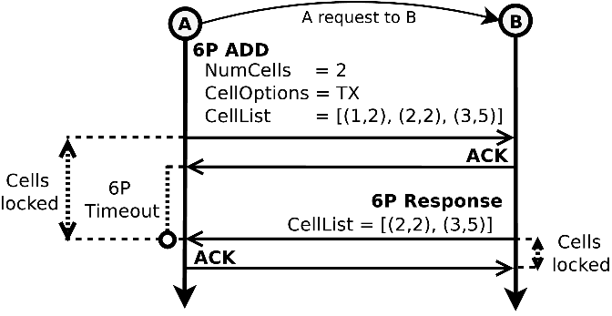

In a **finally successful** **2-step** 6P ADD transaction for one cell, what is the **minimum number** of **packet transmissions attempts** that are made when **3 MAC layer retransmissions** are configured?

Note 1: The ACKs in TSCH cells are counted as a separate transmission attempt.

Note 2: The answer refers to the total number of packet transmissions attempts by both nodes A and B.

1 point

Minimum packet transmission attempts = 8

Minimum packet transmission attempts = 3

Minimum packet transmission attempts = 16

Minimum packet transmission attempts = 2

Minimum packet transmission attempts = 4

Minimum packet transmission attempts = 12

### 2.

Question 2

Use the example of a 2-step ADD transaction below:

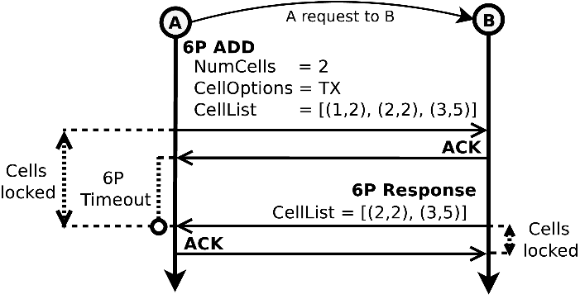

In a **finally successful** **2-step** 6P ADD transaction for one cell, what is the **maximum number** of packet transmissions attempts that are made when **3 MAC layer retransmissions** are configured?

Note 1: The ACKs in TSCH cells are counted as a separate transmission attempt.

Note 2: The answer refers to the total number of packet transmissions attempts by both nodes A and B.

2 points

Maximum packet transmission attempts = 6

Maximum packet transmission attempts = 4

Maximum packet transmission attempts = 16

Maximum packet transmission attempts = 10

Maximum packet transmission attempts = 8

Maximum packet transmission attempts = 12

### 3.

Question 3

In MSF, using the autonomous cells, when do both the Rx (reception) as well as the Tx (transmission) cells constitute reliable contention-less communication?

1 point

It depends: It can be configured as desired by the network administrator

Never

Always

It depends on initialisation phase of the node

### 4.

Question 4

## **When does MSF dynamically adapt the number of negotiated cells of each node (select all that apply):**

3 points

When the node wants to optimise the order of cells to reduce latency.

When the available link-layer resources need to be adapted to the current traffic load.

When a new preferred parent is selected, as part of RPL operations.

When another node, which needs more cells to this node, asks for more cells.

When certain cells experiencing excessive schedule collisions need to be relocated.

When the root / coordinator node asks all other nodes to reset their cells.

### 5.

Question 5

**We have the following scenario:**

A minimal network with two nodes, **A** and **B**.

Initially, **B is sending data to A** at a **constant rate** of **55 packets per slotframe of 100 timeslots**. At this initial point, B has already allocated **55 negotiated TX** (transmission) cells towards A, and correspondingly B has allocated **55 negotiated RX** (reception) cells from B.

**Assume the following:**

* The communication has no collissions and the link quality is perfect (no packet losses) at 100%.
* No MAC layer (0) retransmissions are used.
* MAX_NUM_CELLS, LIM_NUMCELLSUSED_HIGH and LIM_NUMCELLSUSED_LOW are respectively, 100, 75 and 25, as recommended in [RFC 9033](https://datatracker.ietf.org/doc/rfc9033/).

**We progressively increase the traffic rate (packets per slotframe) from B to A in integral steps:**

* 56 packets per slotframe,
* 57 packets per slotframe,
* etc.

**A new negotatied cell from B to A will be requested by MSF when we arrive at which rate?**

3 points

Immediately

When the traffic rate reaches 76 packets per slotframe

Never

When the traffic rate reaches 75 packets per slotframe

When the traffic rate reaches 57 packets per slotframe

When the traffic rate reaches 74 packets per slotframe

**Quiz on the MSF parameter**

**1.**

Question 1

In MSF, and with **constant traffic**, we set:

* **MAX_NUM_CELLS = 100**, and
* **LIM_NUMCELLSUSED_HIGH = LIM_NUMCELLSUSED_LOW = 50**

**Which of the following would happen after enough time passes that all allocations of negotiated cells are completed?**

1 point

We would allocate exactly half the amount of negotiated cells minimally required.

We would allocate exactly the amount of negotiated cells minimally required.

We would allocate exactly double the amount of negotiated cells minimally required.

**2.**

Question 2

In MSF, and with **constant traffic**, we set:

* **MAX_NUM_CELLS = 100**, and
* **LIM_NUMCELLSUSED_HIGH = LIM_NUMCELLSUSED_LOW = 50**

We then allow enough time to pass so that all allocations of negotiated cells are completed.

**What happens if we keep the same *LIM_NUMCELLSUSED_LOW* value (50) but increase LIM_NUMCELLSUSED_HIGH to 51?**

1 point

Nothing changes.

A new negotiated cell is requested by MSF.

An existing negotiated cell is deallocated by MSF.

**3.**

Question 3

In MSF, and with **constant traffic**, we first set:

* **MAX_NUM_CELLS = 100**, and
* **LIM_NUMCELLSUSED_HIGH = LIM_NUMCELLSUSED_LOW = 50**

and allow enough time to pass so that all allocations of negotiated cells are completed.

**What happens if we keep the same LIM_NUMCELLSUSED_LOW value (50) but decrease LIM_NUMCELLSUSED_HIGH to 49?**

1 point

Nothing changes.

A new negotiated cell is requested by MSF.

An existing negotiated cell is deallocated by MSF.

**4.**

Question 4

In MSF, and with **burstry and very variable traffic even within a single slotframe**, we first set:

* **MAX_NUM_CELLS = 100**, and
* **LIM_NUMCELLSUSED_HIGH = LIM_NUMCELLSUSED_LOW = 50**

**What happens? (select all that apply)**

2 points

Existing negotiated cells are constantly getting deallocated by MSF

The number of allocated cells stabilises to the double of the average number of cells required.

The traffic rate of 6P packets exchanged remains high over time.

No packets are lost since MSF always allocates the needed resources quickly.

New negotiated cells are constantly getting allocated by MSF

The traffic rate of 6P packets exchanged becomes lower over time, tending to zero.

Packets may be lost due to packet queues overflow.

The number of allocated cells stabilises to the average number of cells required.

**Quiz on the connection process**

**1.**

Question 1

Consider the following scenario:

We have a node that is configured to communicate on one of the **16 TSCH channels (channel offsets 0 to 15)** with **10ms timeslots**.

We want it to connect to a specific network, with a specific network ID. This network sends an **EB regularly** every **32 seconds**.

We power-on the node and we want to measure the time that it will need to synchronise with the desired network (the one that has the desired network ID).

The timeout for **scanning on a channel** to find an EB is **1 second**, and switching channels is instantaneous.

Also, the **network** we are looking for is the **only one in range** of the new node; there are no other networks.

**What is the minimum possible time required to synchronise to the desired network?**

1 point

10 ms

8 seconds

32 seconds

1 second

Instantly

16 seconds

**2.**

Question 2

During the parent cell allocation step (5), the node uses 6P to request from the parent a negotiated cell. This initial 6P request occurs over autonomous cells which are removed after transmission. Subsequent 6P requests will occur on any of the negotiated cells to the preferred parent.

**What advantages and disadvantages does this approach have? (select all that apply)**

3 points

The autonomous cells will take time to be removed.

The negotiated cell is less reliable.

The negotiated cell is more reliable.

Deleting the autonomous cells will liberate space in the node’s memory.

Changing parents can be done instantly even if if the new parent doesn’t already have another negotiated cell.

The autonomous cells can be removed instantly.

Changing parents will take some time if the new parent doesn’t already have another negotiated cell.

**Week 3: 6LoWPAN adaptation layer**

**Quiz on IPv6 header format**

**.**

Question 1

60 00 00 00 00 06 3a 40 fe 80 00 00 00 00 00 00 02 02 00 02 00 02 00 02 ff 02 00 00 00 00 00 00 00 00 00 00 00 00 00 1a 9b 00 65 19 00 00

Considering the hexadecimal IPv6 packet above, identify properly and match to the IPv6 fields.

1 point

Version : 60 00 00 Traffic Class : 0 Flow Label : 0 00 0 Payload Length : 6 Next Header : 3a 40 Hop Limit : fe Source Address : 80 00 00 00 00 00 00 02 02 00 02 00 02 00 02 ff Destination Address : 02 00 00 00 00 00 00 00 00 00 00 00 00 00 1a 9b Payload : 00 65 19

Version : 6 00 Traffic Class : 0 00 00 Flow Label : 0 0 Payload Length : 06 3a Next Header : 40 Hop Limit : fe 80 Source Address : 00 00 00 00 00 00 02 02 00 02 00 02 00 02 ff 02 Destination Address : 00 00 00 00 00 00 00 00 00 00 00 00 00 1a 9b 00 Payload : 65 19 00 00

Version : 60 Traffic Class : 0 00 Flow Label : 0 00 Payload Length : 00 Next Header : 06 3a Hop Limit : 40 fe Source Address : 80 00 00 00 00 00 00 02 02 00 02 00 02 00 02 Destination Address : ff 02 00 00 00 00 00 00 00 00 00 00 00 00 00 Payload : 1a 9b 00 65 19 00 00

Version : 6 Traffic Class : 0 0 Flow Label : 0 00 00 Payload Length : 00 06 Next Header : 3a Hop Limit : 40 Source Address : fe 80 00 00 00 00 00 00 02 02 00 02 00 02 00 02 Destination Address : ff 02 00 00 00 00 00 00 00 00 00 00 00 00 00 1a Payload : 9b 00 65 19 00 00

Version : 3a Traffic Class : 0 00 00 Flow Label : 0 0 Payload Length : 00 06 Next Header : 6 Hop Limit : 40 ff Source Address : 02 00 00 00 00 00 00 00 00 00 00 00 00 00 1a Destination Address : fe 80 00 00 00 00 00 00 02 02 00 02 00 02 00 02 Payload : 9b 00 65 19 00 00

**Quiz on 6LoWPAN**

**1.**

Question 1

The 6LoWPAN Adaptation layer is located between the:

1 point

MAC (i.e., IEEE Std. 802.15.4) and Phyical (e.g., IEEE Std. 802.15.4) layers.

Application and Transport (e.g., UDP) layers.

Network (i.e., IPv6) and MAC (i.e., IEEE Std. 802.15.4) layers.

Transport (e.g., UDP) and Network (i.e., IPv6) layers.

Application and Network (i.e., IPv6) layers.

**2.**

Question 2

6LoWPAN Adaptation layer was defined to enable IPv6 packet transmission over IEEE Std 802.15.4-based networks.

1 point

False

True

**3.**

Question 3

The 6LoWPAN adaptation layer is in charge for (*select two options*):

1 point

which device is the final destination.

how to compress an IPv6 packet.

which device will transmit a packet.

how many packets a device will transmit.

when a device will transmit an IPv6 packet.

how to fragment an IPv6 packet.

**4.**

Question 4

A compression operation:

1 point

synchronizes the receiver clocks.

reduces the IPv6 and UDP headers.

delivers a frame to the destination endpoint.

indicates the end of a frame.

allows detection of corrupted data.

devides an IPv6 packet to fragments of 127 bytes each.

**5.**

Question 5

A fragmentation operation:

1 point

delivers a frame to the destination endpoint.

devides an IPv6 packet to fragments of 127 bytes each.

synchronizes the receiver clocks.

indicates the end of a frame.

allows detection of corrupted data.

reduces the IPv6 and UDP headers.

**6.**

Question 6

The Mesh-Under and/or Route-Over technique:

1 point

reduces the IPv6 and UDP headers.

synchronizes the receiver clocks.

devides an IPv6 packet to fragments of 127 bytes each.

indicates the end of a frame.

delivers a frame to the destination endpoint.

allows detection of corrupted data.

**Quiz on 6LoWPAN compression operation**

**1.**

Question 1

Which IPv6 fields could be the most efficiently compressed (in terms of elided bytes) when 6LoWPAN compression mechanism (i.e., RFC 6282) applied (*select two options*):

1 point

Source Address

Flow Label

Payload Length

Traffic Class

Next Header

Hop Limit

Version

Destination Address

**2.**

Question 2

A device **A** transmits information at the application layer (e.g., sensor measurements) with size of 17 bytes to a device **B**. As expected, each layer adds the following extra header bytes accordingly:

* UDP adds 8 bytes
* IPv6 adds 40 bytes
* 6LoWPAN compresses **both** IPv6 **and** UDP headers to 7 bytes

What is the total number of bytes received at the **IEEE Std 802.15.4** protocol from the upper layerswhen 6LoWPANcompression scheme **is** **not** employed?

1 point

70 bytes

24 bytes

69 bytes

72 bytes

74 bytes

28 bytes

65 bytes

29 bytes

**3.**

Question 3

A device **A** transmits information at the application layer (e.g., sensor measurements) with size of 17 bytes to a device **B**. As expected, each layer adds the following extra header bytes accordingly:

* UDP adds 8 bytes
* IPv6 adds 40 bytes
* 6LoWPAN compresses **both** IPv6 **and** UDP headers to 7 bytes

What is the total number of bytes received at the **IEEE Std 802.15.4** protocol from the upper layerswhen 6LoWPANcompression scheme **is** employed?

1 point

70 bytes

24 bytes

69 bytes

72 bytes

74 bytes

28 bytes

65 bytes

29 bytes

**4.**

Question 4

Considering that LOWPAN_IPHC encoding mechanism assumes that the values in the IPv6 fields could be the common case to the entire 6LoWPAN, and that they are coming with the following values:

* **Version** is IPv6.
* Both the **Traffic Class** and the **Flow Label** are 0.
* The **Payload Length** is inferred either from the IEEE 802.15.4 header (i.e., "Frame Length") or from the 6LoWPAN Fragmentation header (i.e., "*datagram_size*" field, if present).
* The **Next Header** is ICMP, and it is equal to 0, which indicates that the **NH** field is not compressed, and thus all 8 bits for NH are carried in-line.
* The **Hop Limit** (8 bits) is equal to 56.
* Both **IPv6 source and destination addresses** are formed by employing the *link-local prefix*, and the *Interface IDs* (*IIDs*) that are derived directly from the layer two MAC source and destination addresses (i.e., IEEE Std. 802.15.4 addresses).

This IPv6 header (as presented above) can be compressed to how many bytes?

1 point

6

5

12

16

4

32

2

24

8

40

3

7

**5.**

Question 5

60 00 00 00 00 06 3a 40 fe 80 00 00 00 00 00 00 02 02 00 02 00 02 00 02 ff 02 00 00 00 00 00 00 00 00 00 00 00 00 00 1a 9b 00 65 19 00 00

Considering the hexadecimal IPv6 packet above, where the IPv6 header fields are matched as presented below.

Version : 6 Traffic Class : 0 0 Flow Label : 0 00 00 Payload Length : 00 06 Next Header : 3a Hop Limit : 40 Source Address : fe 80 00 00 00 00 00 00 02 02 00 02 00 02 00 02 Destination Address : ff 02 00 00 00 00 00 00 00 00 00 00 00 00 00 1a Payload : 9b 00 65 19 00 00

Create the ***Binary*** version 6LoWPAN LOWPAN_IPHC Compressed Header ***along with the inline values*** (the ***payload is not necessary***). Some tips to facilitate your journey (feel free to use Hexadecimal to Binary Converter):

* The source address is stateless and fully compressed.
* The destination address is stateless, partially compressed and only 8-bits are sent inline.

**Quiz on fragmentation and reassembly operations**

**1.**

Question 1

Considering a multi-hop line topology with A, B and C nodes, where A is the source endpoint, B is the intermediate node, and C is the destination endpoint, an IPv6 packet that is fragmented to 4 fragments, what will happen if at least one fragment will be lost (at the 6LoWPAN layer), i.e., the destination endpoint will receive any 3 out of 4 fragments?

1 point

The destination endpoint will abort the reassembly operation and will discard the received fragments, if it not receives all 4 fragments within the reassembly time (i.e., 60 seconds).

The intermediate node will request (at the 6LoWPAN layer) from the source endpoint to retransmit the missing fragment.

The intermediate node will recover the lost fragment from the received fragments (e.g., based on a Forward Error Correction (FEC) technique), and will proceed to the reassembly operation.

The destination endpoint will wait for an infinite time for the 4th fragment.

The destination endpoint will proceed with reassembly operation.

**2.**

Question 2

Considering a multi-hop line topology with A, B and C nodes, where A is the source endpoint, B is the intermediate node, and C is the destination endpoint, an IPv6 packet that is fragmented to 4 fragments, and each fragment is transmitted to the next hop (i.e., from A to B, and from B to C) ***with 0 MAC layer retransmission***. What will happen if, for example, a fragment is unsuccessfully transmitted (at the MAC layer) from the source endpoint to the intermediate node?

1 point

The intermediate node will request (at the 6LoWPAN layer) from the source endpoint to retransmit the missing fragment.

The intermediate node will expect for the MAC layer retransmission of the unsuccessful fragment transmisison.

The intermediate node will proceed with reassembly operation.

The intermediate node will recover the lost fragment from the received fragments (e.g., based on a Forward Error Correction (FEC) technique), and will proceed to the reassembly operation.

The intermediate node will abort the reassembly operation and will discard the received fragments, if it not receives all 4 fragments within the reassembly time (i.e., 60 seconds).

**3.**

Question 3

Considering a multi-hop line topology with A, B and C nodes, where A is the source endpoint, B is the intermediate node, and C is the destination endpoint, an IPv6 packet that is fragmented to 4 fragments, and each fragment is transmitted to the next hop (i.e., from A to B, and from B to C) ***with 3 MAC layer retransmissions***. What will happen if, for example, a fragment is unsuccessfully transmitted (at the MAC layer) from the source endpoint to the intermediate node?

1 point

The intermediate node will expect for the MAC layer retransmission of the unsuccessful fragment transmisison.

The intermediate node will proceed with reassembly operation.

The intermediate node will request (at the 6LoWPAN layer) from the source endpoint to retransmit the missing fragment.

The intermediate node will recover the lost fragment from the received fragments (e.g., based on a Forward Error Correction (FEC) technique), and will proceed to the reassembly operation.

The intermediate node will abort the reassembly operation and will discard the received fragments, if it not receives all 4 fragments within the reassembly time (i.e., 60 seconds).

**4.**

Question 4

Consider a scenario where the device A will transmit an IPv6 datagram, which contains the already compressed by 6LoWPAN application data of 1280 bytes to device B. Note that IEEE 802.15.4 allows a MTU of 127 bytes. How many transmissions will be required to send the IPv6 datagram of 1280 bytes, when the first fragment header consists of 4 bytes while the subsequent fragment headers consist of 5 bytes, IEEE 802.15.4 MAC header consists of 23 bytes, and finally Frame Check Sequence (FCS) consists of 2 bytes?

1 point

9.48

11.48

10

9

12.18

12

11

10.48

13

**5.**

Question 5

An intermediate node B allocates 3840 bytes for buffering the fragments for reassembly purposes. How many IPv6 packets the node B may handle concurrently when each IPv6 packet comes with **8 fragments**? Note that each fragment consists of 127 bytes.

1 point

8

10

6

3

2

9

4

1

7

5

**Quiz on mesh under and route over**

**1.**

Question 1

In the Mesh-Under mode, the routing and forwarding operations are performed at:

1 point

Physical Layer.

Data Link Layer (i.e., MAC).

6LoWPAN Adaptation Layer.

Network (i.e., IPv6 Layer).

Transport Layer

**2.**

Question 2

In the Route-Over mode, the routing and forwarding operations are performed at:

1 point

Physical Layer.

Data Link Layer (i.e., MAC).

6LoWPAN Adaptation Layer.

Network (i.e., IPv6 layer).

Transport Layer.

**3.**

Question 3

In the Mesh-Under mode, in order to perform the routing and forwarding operations ...

1 point

The Layer-2 addresses are employed.

Both Layer-2 and Layer-3 addresses are employed.

The Layer-3 addresses are employed.

**4.**

Question 4

The reassembly operation is done ***only*** at the destination node and not at each intermediate node.

1 point

For the Route-Over mode.

For both the Route-Over mode and the Mesh-Under mode.

For the Mesh-Under mode.

For neither the Route-Over mode nor the Mesh-Under mode.

**5.**

Question 5

In a multi-hop network of *n* hops, the fragment delivery probability is higher with the:

1 point

Route-Over mode, because at each intermediate node the IPv6 packet is reassembled, and later fragmented again to be transmitted with the initial probability.

Mesh-Under mode, because at each intermediate node the IPv6 packet is reassembled, and later fragmented again to be transmitted with the initial probability.

Mesh-Under mode, because the intermediate nodes share the same prefix.

Mesh-Under mode, because the fragment delivery probability increases after traversing each intermediate node gradually.

Route-Over mode, because the there is not reassembly and fragmentation operations at each intermediate node.

**6.**

Question 6

In a multi-hop network of *n* hops, the IPv6 packet (which is fragmented in 6 fragments) delivery latency is higher with the:

1 point

Mesh-Under mode, because at each intermediate node the IPv6 packet is reassembled, and later fragmented again to be forwarded.

Route-Over mode, because at each intermediate node the IPv6 packet is reassembled, and later fragmented again to be forwarded.

Mesh-Under mode, because the fragment delivery time decreases after traversing each intermediate node gradually.

Mesh-Under mode, because the intermediate nodes share the same prefix.

Route-Over mode, because the there is not reassembly and fragmentation operations at each intermediate node.

**7.**

Question 7

In 6LoWPAN the *datagram tag* is unique only to the 6LoWPAN original source and destination endpoints. As a result, two different traffic flows may be *tagged* with the same value, which could introduce implementation issues during the storing fragment forward state. What is the probability that two source endpoints will select the same *datagram tag*, when a *datagram tag* consists of 16 bits, i.e., see "RFC 4944: 6LoWPAN Fragmentation and Reassembly Operations" reading? Note that the *datagram* *tag* is chosen randomly, according to a uniform distribution, and there are no forbidden values like all-ones or all-zeros.

1 point

2 * (1/16)

2 * (1/65536)

2 * (1/65536) * (1/65536)

2 * (1/16) * (1/16)

(1/16) * (1/16)

(1/65536) * (1/65536)

1/16

1/65536

**Quiz on 6LFF**

**1.**

Question 1

The size of a VRB table is equal to:

1 point

20 Bytes.

the size of the IPv6 packets in its VRB table.

the size of the entries in its VRB table.

3840 Bytes.

the size of the MAC addresses in its VRB table.

1280 Bytes.

the size of the *datagram_tags* in its VRB table.

**2.**

Question 2

In VRB method, each intermediate node reassembles and then fragments the IPv6 packets before forwarding to the next hop.

1 point

True

False

**3.**

Question 3

According to the RFC 8930, by employing the VRB method, what will happen to the subsequent fragment, if the 1st fragment is never received at an intermediate node?

1 point

The intermediate node will proceed with reassembly operation.

The intermediate node will wait for an infinite time for the 1st fragment.

The intermediate node will abort the reassembly operation and will discard the received fragments, if it not receives all fragments (including the 1st one) within the reassembly time (i.e., 60 seconds).

The intermediate node will recover the lost fragment from the received fragments (e.g., based on a Forward Error Correction (FEC) technique), and will proceed to the reassembly operation.

The intermediate node will not be able to create a new entry in its VRB table, and thus, it will not be able to forward the subsequent fragments to the next hop.

The intermediate node will not receive the remaining fragments, and it will discard the stale 6LFF state after the timer's timeout.

**4.**

Question 4

Considering a multi-hop mesh topology, where each node in the network has at least 3 potential parents, and an IPv6 datagram that is fragmented to 6 fragments at the source endpoint. The fragment forwarding is based on the VRB method. What will happen for an intermediate node if the routing will change while the 6 fragments are being forwarded toward the destination endpoint?

1 point

The intermediate node will proceed with reassembly operation.

The intermediate node will wait for an infinite time for the 1st fragment.

The intermediate node will abort the reassembly operation and will discard the received fragments, if it not receives all fragments (including the 1st one) within the reassembly time (i.e., 60 seconds).

The intermediate node will recover the lost fragment from the received fragments (e.g., based on a Forward Error Correction (FEC) technique), and will proceed to the reassembly operation.

The intermediate node will not be able to create a new entry in its VRB table, and thus, it will not be able to forward the subsequent fragments to the next hop.

The intermediate node will not receive the remaining fragments, and it will discard the stale 6LFF state after the timer's timeout.

**5.**

Question 5

An intermediate node B allocates 3840 bytes for buffering the fragments for reassembly purposes. How many IPv6 packets the node B may handle concurrently when each IPv6 packet comes with **8 fragments**, when the VRB method is applied? Note that each fragment consists of 127 bytes, and each VRB entry requires 20 bytes of memory.

1 point

24

3

4

192

1

31

30

2

224

164

**6.**

Question 6

6LFF (i.e., RFC 8930) when is compared against the Route-Over (Per-hop Fragmentation and Reassembly), i.e., RFC 4944, approach, it:

1 point

Increases the end-to-end latency and decreases the network reliability (i.e., PDR).

Increases the end-to-end latency and the network reliability (i.e., PDR).

Decreases the end-to-end latency and increases the network reliability (i.e., PDR).

Decreases the end-to-end latency and the network reliability (i.e., PDR).

**Quiz on 6LoWPAN selective fragment recovery**

**1.**

Question 1

Which drawbacks of 6LFF (i.e., RFC 8930) does 6LoWPAN Selective Fragment Recovery (i.e., RFC 8931) address?

1 point

No Per-Fragment Routing.

No Fragment Recovery.

Non-zero Packet Drop Probability.

**2.**

Question 2

Why defining ***new*** Dispatch types in RFC 8931, in addition to the already defined dispatch types defined in RFC 4944, is an issue (*select three options*)?

1 point

Because not many Dispatch types options are left for the upcoming proposals at the IETF.

Because it allows to handle large-scale 6LoWPANs.

Because it enhances the end-to-end network reliability.

Because it introduces backward compatibility issues with the existing standard(s), e.g., RFC 4944.

Because it increases the complexity in 6LoWPAN.

**3.**

Question 3

Selective fragment recovery mechanism:

1 point

Decreases the end-to-end latency and increases the network reliabiliy.

Decreases the end-to-end latency and the network reliabiliy.

Increases the end-to-end latency and the network reliabiliy.

Increases the end-to-end latency and decreases the network reliabiliy.

**4.**

Question 4

The selective fragment recovery mechanism [RFC 8931] groups the fragments of an IPv6 datagram in Windows and requests intermediate acknowledgments. The size of the window is configurable. Considering an IPv6 packet that is fragmented into 9 fragments, and the Window is equal to 3. How many RFRAG Acknowledgment (RFRAG-ACK) will transmitted from the destination endpoint toward the source endpoint?

1 point

5

2

1

3

6

4

**Quiz on practice lab**

### 1.

Question 1

## **Context: Impact of fragmentation and link quality on the One-hop network**

Network topology:

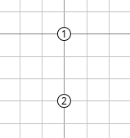

Note the following:

* We are using normal RPL and TSCH.
* We are using 0 MAC layer retransmissions.
* The TSCH schedule is assumed to allow one packet to be forwarded to each node’s parent per slotframe, i.e. there are no allocated cells for retransmissions.
* The sending node will continue to send packets to the destination node irrespective if it has a connection (i.e. a default routing path) to it. Packets sent when there is no default path are lost and not sent at all.

### For the one-hop network, this is the plot of the Delay vs Link quality for the different payload sizes:

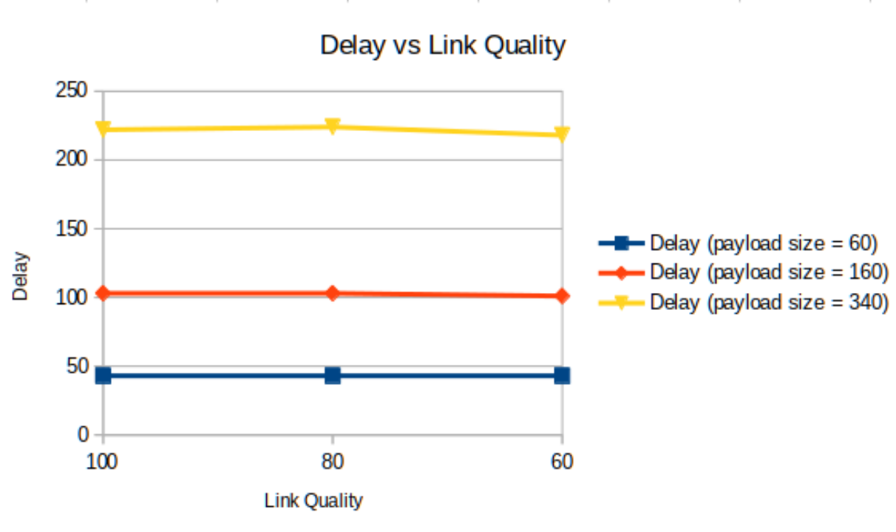

### What would change in the previous Delay vs Link quality plot if we allowed 1 retransmission (reTX) (that is, 2 TXs in total) but kept the exact same TSCH schedule with one transmission opportunity per link?

1 point

Latency would increase as link quality decreases

The plot values would not significantly change

Latency would overall decrease due to more transmissions